

ESSAY 2 – Topic 4

Author: Bertocco Thomas-Killian - #13758322

Lecturer: Adrian Bradshaw

ELPP 4 | Semester 1 | 2019

5/23/2019

The evolution of artificial intelligence, and its impacts on the business environment

Table of Contents

Introduction 3

What factors influence the development of artificial intelligence? 4

The increase in research 4

The increase in computing power 5

The amount of data available 5

What are the Impacts of Artificial intelligence on the business environment? 6

Robotisation and automatisation 6

Predictions and decision making 7

Employment 8

Global economic impact by sectors 9

Conclusion 11

References 12

# Introduction

Artificial intelligence or cognitive computing is the search for ways to equip computer systems with intellectual capacities comparable to those of human beings.

By the mid-1960s, research into AI was mainly funded by the Department of Defense of the US. At the same time, laboratories are opening here and there around the world. Some experts predicted at the time that "machines will be able, within 20 years, to do the work that anyone can do. If the idea was visionary, even in 2019 artificial intelligence has not yet taken on this importance in our lives. Although it has not been able to replace the human being, it has nevertheless made itself useful and even essential in many areas. Its impact on the economy and the business environment is significant enough to have triggered competition between the various world powers, in order to develop the most efficient artificial intelligence.

How does the Artificial intelligence technology evolve, and what are its Impacts on the business environment?

# What factors influence the development of artificial intelligence?

## The increase in research

Artificial intelligence has become a major strategic and economic asset. All developed countries have continued to increase the budget dedicated to the development of this technology in order to stay in the race. Between 1996 and 2017, AI papers submissions have increased 7x times, while cs papers increased 5x during the same period (AIindex, 2018).

The 3 major players involved in its development are China, the USA and Europe.

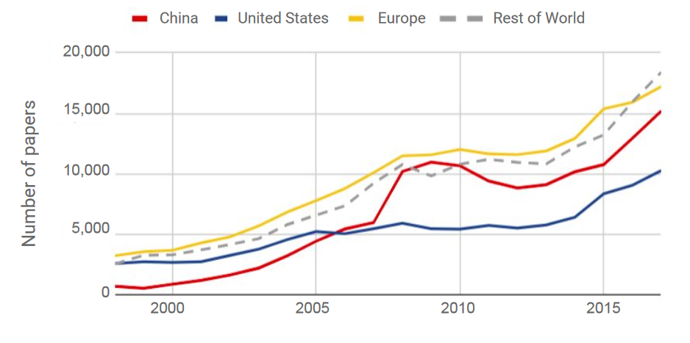

Figure 1. aiindex.org (2018). Annually published AI papers on Scopus by region (1998—2017). http://cdn.aiindex.org/2018/AI%20Index%202018%20Annual%20Report.pdf

Despite China's efforts, Europe has always been the largest publisher of AI-related articles. However, it is American research that has the greatest impact. U.S. authors are cited 83% more than the global average (AIindex, 2018).

Because it is the home of many major IT companies, the United States is the only region where most research is conducted by private companies.

## The increase in computing power

As early as 1965, Gordon Moore, co-founder of Intel Corporation, said that the number of transistors per circuit of the same size would double, at constant prices, every eighteen months. He deduced from this that the power of computers would grow exponentially for years to come. He was right. Its law, based on empirical observation, has been verified to this day.

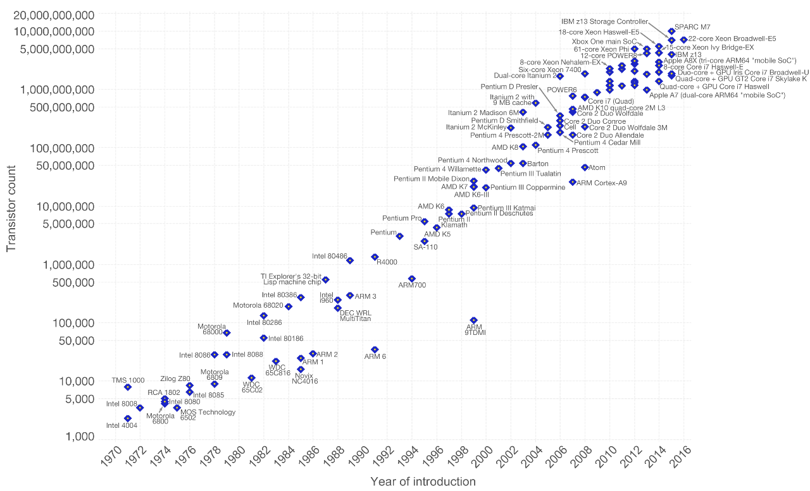

Figure 1. wikipedia.org (2018). Moore's Law Transistor Count 1971-2016. https://en.wikipedia.org/wiki/Moore%27s_law

Thanks to this phenomenon, the computing power of AI has also increased drastically. It is able to process more data in less time, which means she can train faster to produce better quality analysis and predictions.

## The amount of data available

With the revolution of social media, e-commerce, and monitoring solutions, the amount and the variety of data collected by companies/governments rose significantly. Platforms such as Android, Amazon, Facebook, Baidu or Google, allow data to be collected on billions of users automatically. The data collected allows AI projects to be created in new areas, and existing AIs to be optimized. The more data it has, the more accurate it becomes.

For example, Google's voice recognition technology has greatly improved after partnering with Microsoft, IBM, Amazon and Facebook, allowing it to access billions of new data.

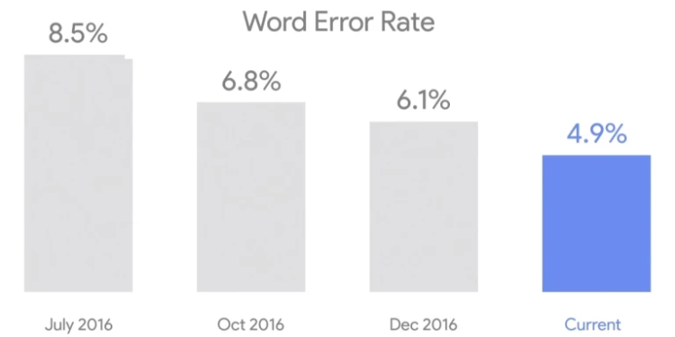

Figure 1. venturebeat.com (2018). Google’s speech recognition evolution. https://venturebeat.com/2017/05/17/googles-speech-recognition-technology-now-has-a-4-9-word-error-rate/

Speech recognition error rate fell from 23% in 2013 to 4.9% at the beginning of 2017 (2017, Pichai).

**Same observation for image recognition, error rates for image labelling have fallen from 28.5% to below 2.5% since 2010 (**AIindex, 2017)**.**

# What are the Impacts of Artificial intelligence on the business environment?

## Robotisation and automatisation

AI changes by automating a number of processes, freeing workers from low value-added tasks so they can focus on those that create the most value. In the short term, the most important potential for economic growth related to artificial intelligence lies in increasing productivity (PwC, 2019). This includes automating routine tasks, increasing employees' skills by freeing up time so they can focus on more challenging tasks.

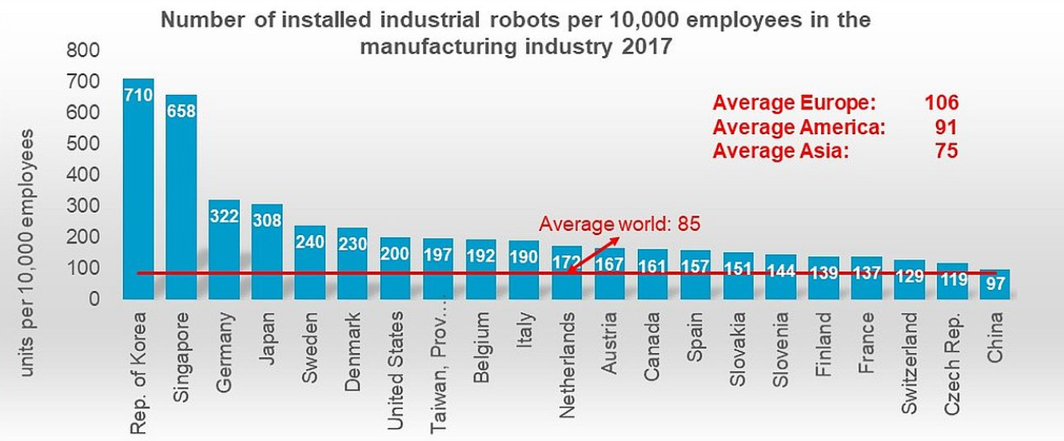

Figure 1. ifr.org (2017). Number of installed industrial robots per 10,000 employees in the manufacturing industry 2017. https://ifr.org/ifr-press-releases/news/global-industrial-robot-sales-doubled-over-the-past-five-years

This is obviously the case in the manufacturing sector, where robotization, coupled with task automation, will make it possible to redeploy employees to positions that create more value for the company. But also, in health, where diagnoses will be facilitated by artificial intelligence, which will be able to detect variations in certain medical indicators and identify anomalies by comparing them with the averages recorded in other patients. This will ease doctors' schedules and allow them to treat more patients.

## Predictions and decision making

Artificial Intelligence will deliver a revolutionary impact on how enterprises make decisions today.

Today, AI-enabled decision-making is more prescriptive, with AI providing enterprises not just a look into the future, but also key diagnostics and suggestions on potential decision options and their payoffs. Such evolved applications of AI can help businesses make decisions that can potentially exploit more business opportunities, while averting potential threats much earlier.

Most companies use this technology for marketing purposes. By analyzing batches of data, the AI will make predictions about the best choices to make.

For example, in the field of e-commerce, the AI will analyze the characteristics of each customer and their behaviour in order to suggest relevant products and maximize profits.

It has been estimated that Amazon’s recommendation engine drives 35 percent of total sales (mckinsey, 2013).

## Employment

According to the World Economic Forum (WEF), about 133m jobs globally could be created with the help of rapid technological advances in the workplace over the next decade, compared with 75m that could be displaced.

In 2025, machines are expected to perform more current work tasks than humans compared to 71% being performed by humans as of now. Due to this transformation, it will have a major impact on the global workforce.

AI already has created thousands of new jobs.

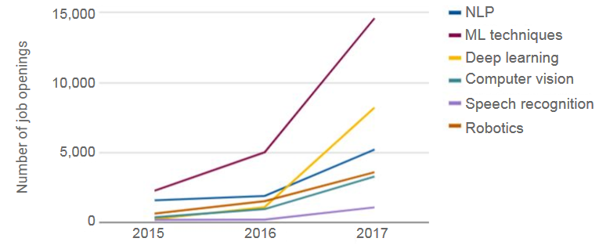

Figure 1. aiindex.org (2018). Growth of job openings by AI skills required (2015 — 2017). http://cdn.aiindex.org/2018/AI%20Index%202018%20Annual%20Report.pdf

While machine learning is the largest skill cited as a requirement, deep learning is growing at the fastest rate. From 2015 to 2017 the number of job openings requiring deep learning increased 34x.

## Global economic impact by sectors

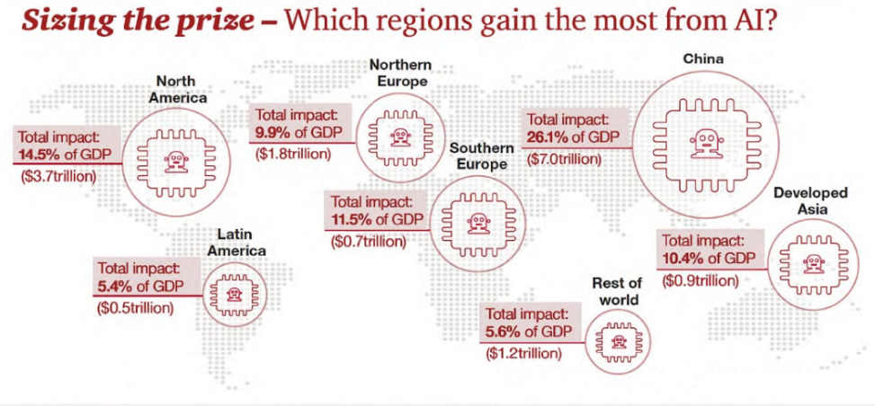

Figure 1. pwc.com (2019). Which regions gain the most from AI. https://www.pwc.com/gx/en/issues/analytics/assets/pwc-ai-analysis-sizing-the-prize-report.pdf

According to 2019 predictions for AI, the technology could bring more than $15 trillion to the global economy by 2030 (PwC, 2019). China alone could benefit from $7 trillion, which is more than a quarter of its GDP.

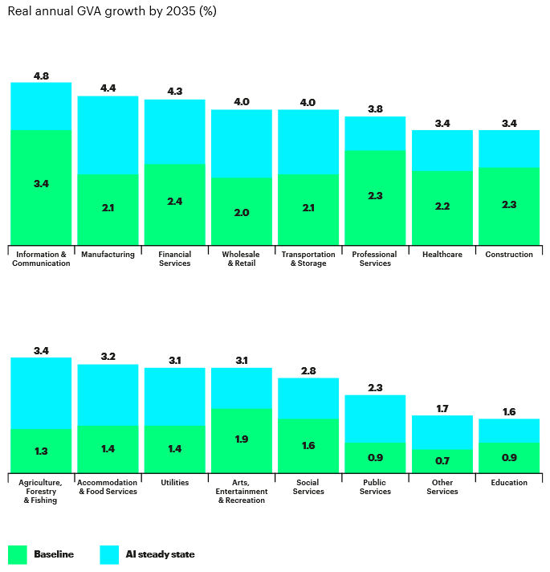

Figure 1. accenture.com (2017). The impact of AI on industry growth. https://www.accenture.com/_acnmedia/PDF-84/Accenture-AI-Industry-Growth-Full-Report.pdf

Of all the sectors studied, information and communication would benefit most from artificial intelligence (with growth in gross value added of 4.8%), ahead of the manufacturing industry (4.4%) and financial services (4.3%). They alone account for $6 trillion in additional gross value added created through AI, almost half of the additional value added created by all sectors. Paradoxically, the sectors whose growth would be the lowest, even if AI was introduced, are also those for which it would boost growth the most strongly: education would see its growth almost double thanks to AI (from 0.9% to 1.6%) and public services almost triple (0.9% to 2.3%).

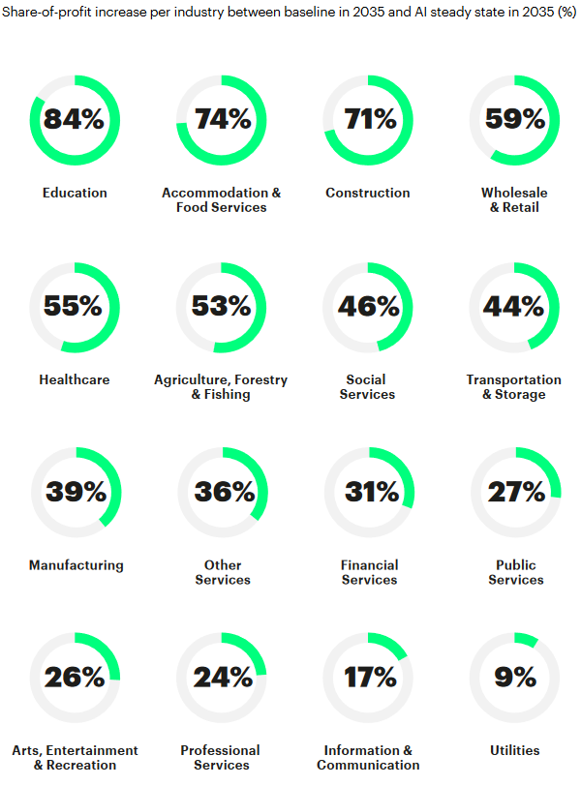

Figure 2. accenture.com (2017). The impact of AI on industry growth. https://www.accenture.com/_acnmedia/PDF-84/Accenture-AI-Industry-Growth-Full-Report.pdf

Beyond growth, some sectors could use AI to significantly optimize their costs and boost their profits. Six out of 16 sectors would see their profits increase by at least half. Education would thus increase by 84%, ahead of hotel and restaurant services (74%), construction (71%), retail (59%), health services (55%) and agriculture (53%). The profits of the sectors that grew most strongly with the introduction of AI are much lower (17% in information-communication, 39% in manufacturing and 31% in financial services).

# Conclusion

The economic impact of AI is likely to be large, comparing well with other general-purpose technologies in history At the same time, there is a risk that a widening AI divide could open up between those who move quickly to adopt these technologies and those who do not use them, and between workers who have the skills that match demand in the AI era and those who don’t. The benefits of AI are likely to be distributed unequally, and if the development and deployment of these technologies are not handled effectively, there could be inequalities, causing conflict within societies.

At present, AI is able to replace the human being for low skill jobs (transport, manufacture, …) and to assist him for more complex tasks (medicine, marketing, ...). This situation will gradually change, and AI coupled with robotics will gradually replace the human in all fields.

# References

Chowdhry, A. (2018, September 18). Artificial Intelligence To Create 58 Million New Jobs By 2022,

Says Report. Retrieved May 22, 2019, from https://www.forbes.com/sites/amitchowdhry/2018/09/18/artificial-intelligence-to-create-58-million-new-jobs-by-2022-says-report/#5b4fbf714d4b

Columbus, L. (2018, January 19). 10 Charts That Will Change Your Perspective On Artificial

Intelligence's Growth. Retrieved May 22, 2019, from

https://www.forbes.com/sites/louiscolumbus/2018/01/12/10-charts-that-will-change-your-

perspective-on-artificial-intelligences-growth/#572bb3964758

Corea, F. (2019). *Applied artificial intelligence: Where AI can be used in business*. Springer.

Duan, Y., Edwards, J. S., & Dwivedi, Y. K. (2019). Artificial intelligence for decision making in the era of Big Data–evolution, challenges and research agenda. *International Journal of Information Management*, *48*, 63-71.

MacKenzie, I. How retailers can keep up with consumers. (2013). Retrieved May 22, 2019, from

https://www.mckinsey.com/industries/retail/our-insights/how-retailers-can-keep-up-with-

consumers

IFR. (2018, October 18). Global industrial robot sales doubled over the past five years. Retrieved May 22,

2019, from https://ifr.org/ifr-press-releases/news/global-industrial-robot-sales-doubled-over-the-

past-five-years

WEF. Insight Report The Future of Jobs Report 2018. Centre for the New Economy and Society. (2018,

May/June). http://www3.weforum.org/docs/WEF_Future_of_Jobs_2018.pdf. *Weforum*. Retrieved May 22, 2019.

Luc, D. (2017, March 08). L'avenir de la loi de Moore. Retrieved May 22, 2019, from

https://medium.com/xxii-group/https-medium-com-david-luc-lavenir-de-la-loi-de-moore-

f7f185652c38

Moore's law. (2019, May 08). Retrieved May 22, 2019, from https://en.wikipedia.org/wiki/Moore's_law

Oav Shoham, Raymond Perrault, Erik Brynjolfsson, Jack Clark, James Manyika, Juan Carlos Niebles, Terah Lyons, John Etchemendy, Barbara Grosz and Zoe Bauer, "The AI Index 2018 Annual Report”, AI Index Steering Committee, Human-Centered AI Initiative, Stanford University, Stanford, CA, December 2018.

Pandey, P. K. (2018). Role of Artificial Intelligence in Business. *Economic Development of India*, *1*(1), 122-139.

Sharma, A. (2017, February 17). How Predictive AI Will Change Shopping. Retrieved May 22, 2019,

from https://hbr.org/2016/11/how-predictive-ai-will-change-shopping

Webster, C., & Ivanov, S. H. (2019). Robotics, artificial intelligence, and the evolving nature of work.

*Business Transformation in Data Driven Societies, Palgrave-MacMillan (forthcoming)*.

Wilson, H. J., Daugherty, P., & Bianzino, N. (2017). The jobs that artificial intelligence will

create. *MIT Sloan Management Review*, *58*(4), 14.

Wladawsky-Berger, I. (2018, November 26). The Impact of Artificial Intelligence on the World

Economy. Retrieved May 22, 2019, from https://blogs.wsj.com/cio/2018/11/16/the-impact-of-artificial-intelligence-on-the-world-economy/